**SINGLE LAYER NEURAL NETWORK :**

**ADAPTIVE LINEAR NEURON USING LINEAR (IDENTITY) ACTIVATION FUNCTION WITH BATCH GRADIENT METHOD**

**ADALINE** (**Adaptive Linear Neuron** or later **Adaptive Linear Element**) is an early single-layer artificial neural network and the name of the physical device that implemented this network.

The network uses memistors.

It was developed by Professor Bernard Widrow and his graduate student Ted Hoff at Stanford University in 1960.

It is based on the McCulloch–Pitts neuron. It consists of a weight, a bias and a summation function.

The difference between Adaline and the standard (McCulloch–Pitts) perceptron is that in the learning phase, the weights are adjusted according to the weighted sum of the inputs (the net).

In the standard perceptron, the net is passed to the activation (transfer) function and the function's output is used for adjusting the weights.

A multilayer network of ADALINE units is known as a **MADALINE.**

**Definition**

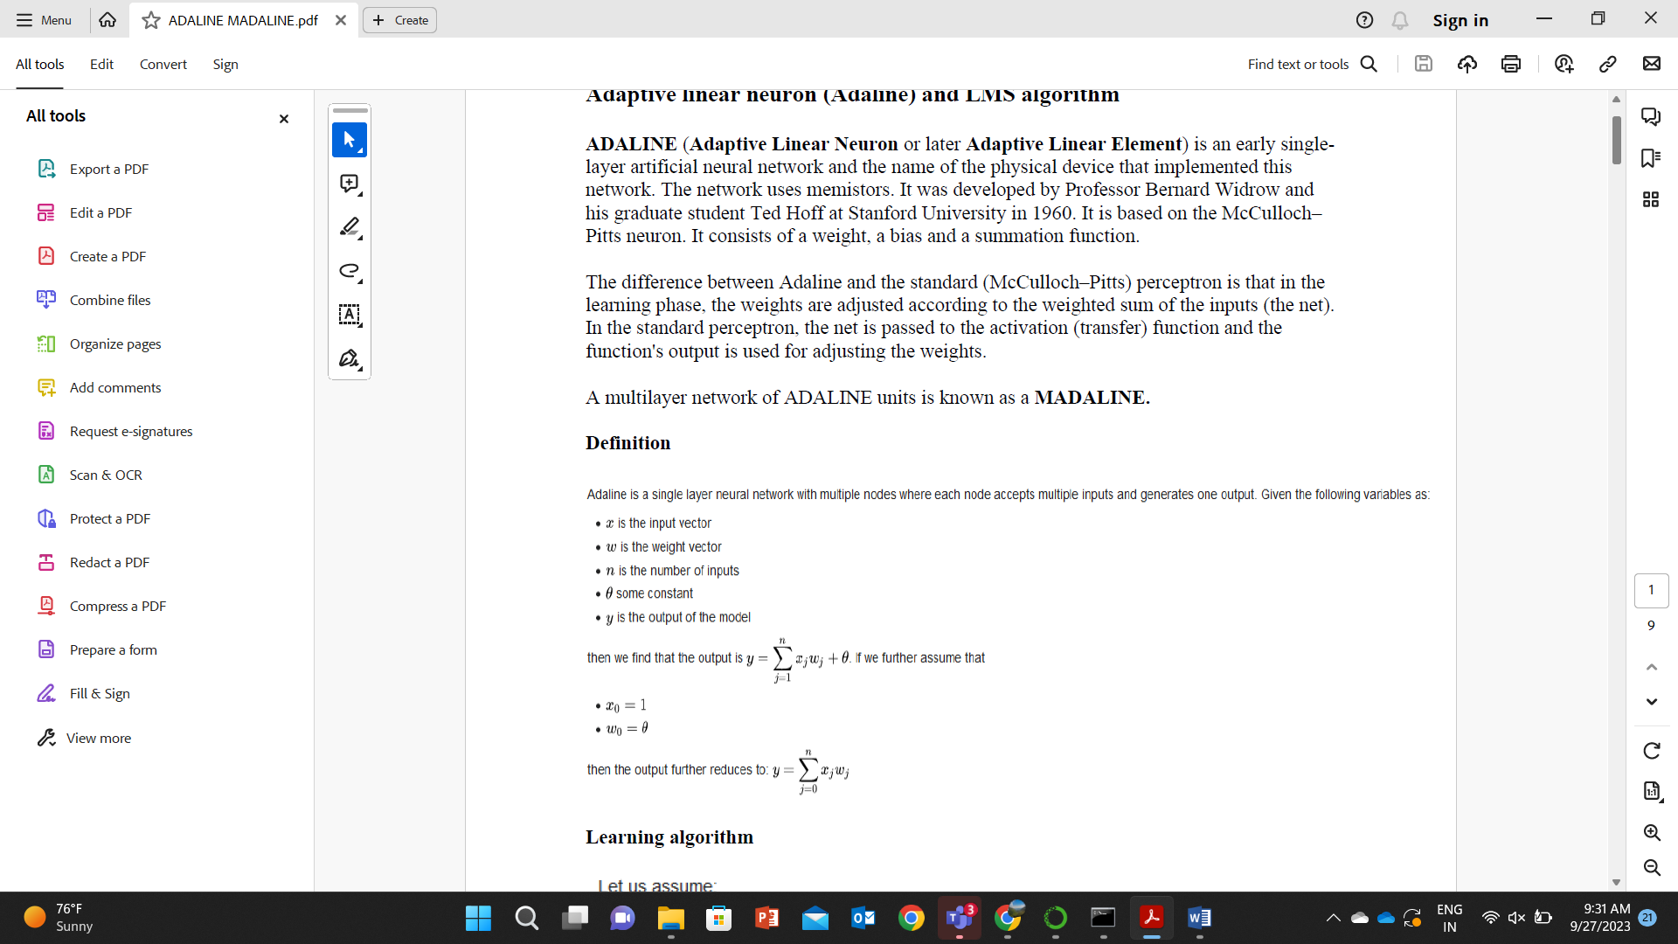

**Learning algorithm**

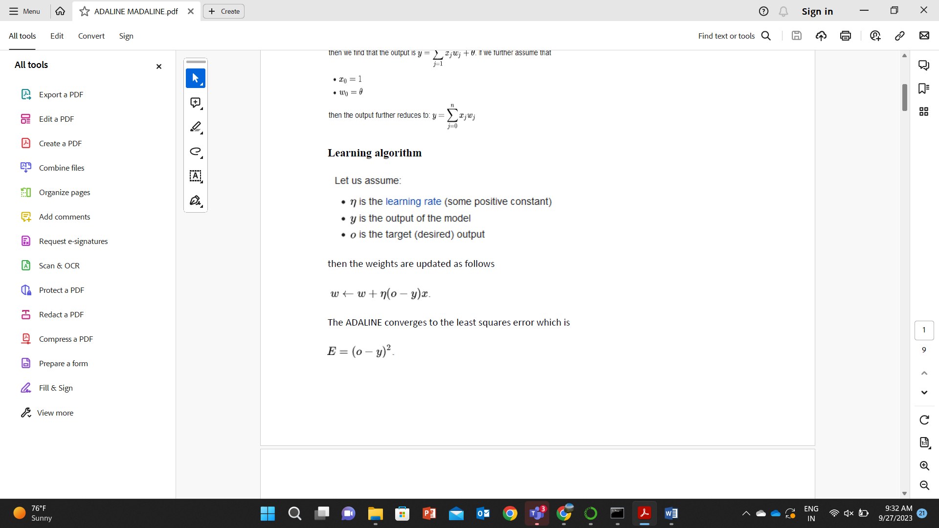

This update rule is in fact the stochastic gradient descent update for linear regression

In this tutorial, we'll learn another type of single-layer neural network (still this is also a **perceptron**) called **Adaline (Adaptive linear neuron)** rule (also known as the **Widrow-Hoff** rule).

The key difference between the Adaline rule (also known as the Widrow-Hoff rule) and Rosenblatt's perceptron is that the weights are updated based on a linear activation function rather than a unit step function like in the Perceptron model.

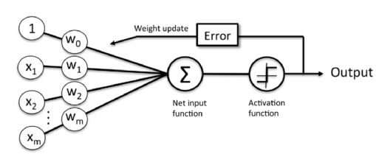

Perceptron

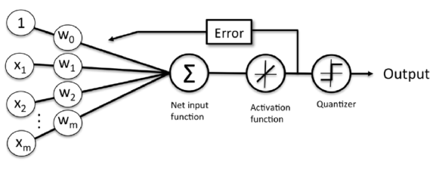

Adaptive linear neuron

The difference is that we're going to use the continuous valued output from the linear activation function to compute the model error and update the weights, rather than the binary class labels.

**Artificial neurons**

The perceptron algorithm enables the model automatically learn the optimal weight coefficients that are then multiplied with the input features in order to make the decision of whether a neuron fires or not.

In supervised learning and classification, such an algorithm could then be used to predict if a sample belonged to one class or the other.

In binary classifiers perceptron algorithm, we refer to our two classes as either 1 (positive class) or -1 (negative class).

In the context of neural networks, a **perceptron** is an **artificial neuron** using the **Heaviside step function** as the activation function.

The perceptron algorithm is also termed the **single-layer perceptron**, to distinguish it from a **multilayer perceptron**. As a linear classifier, the single-layer perceptron is the simplest **feedforward neural network**.

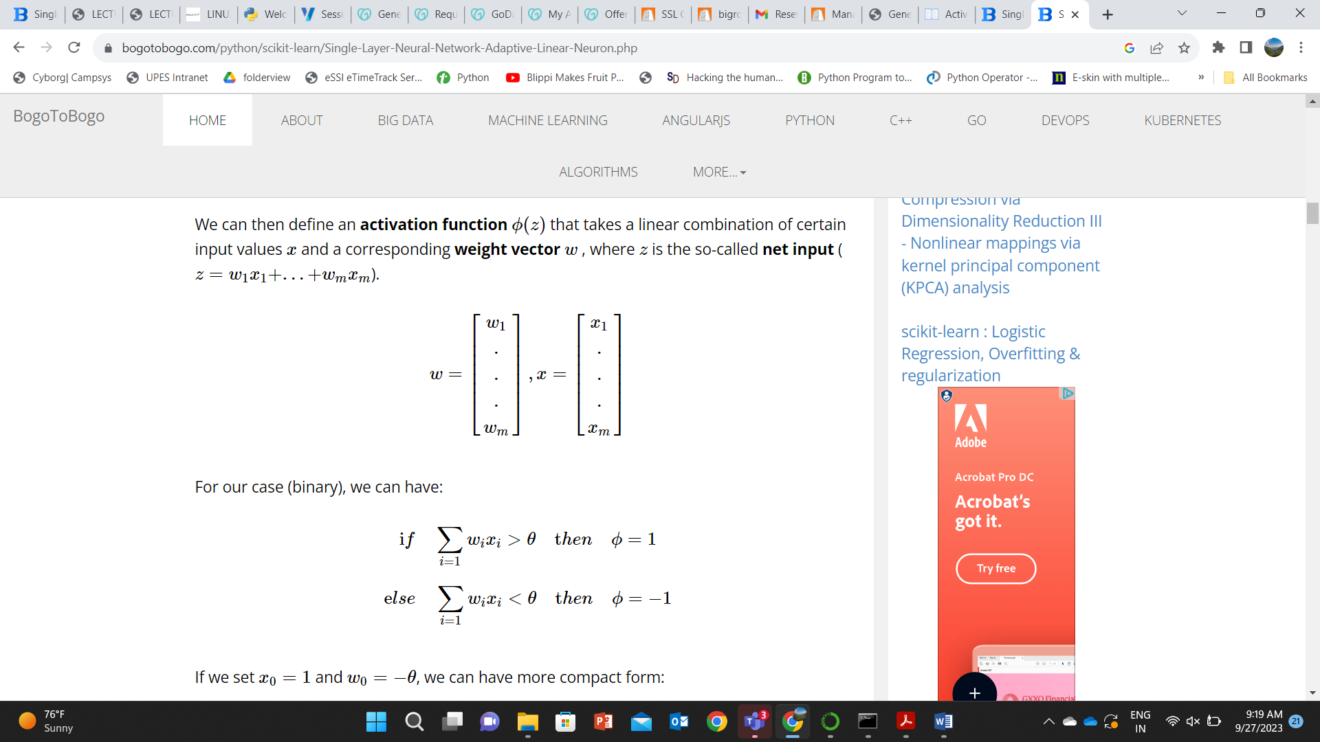

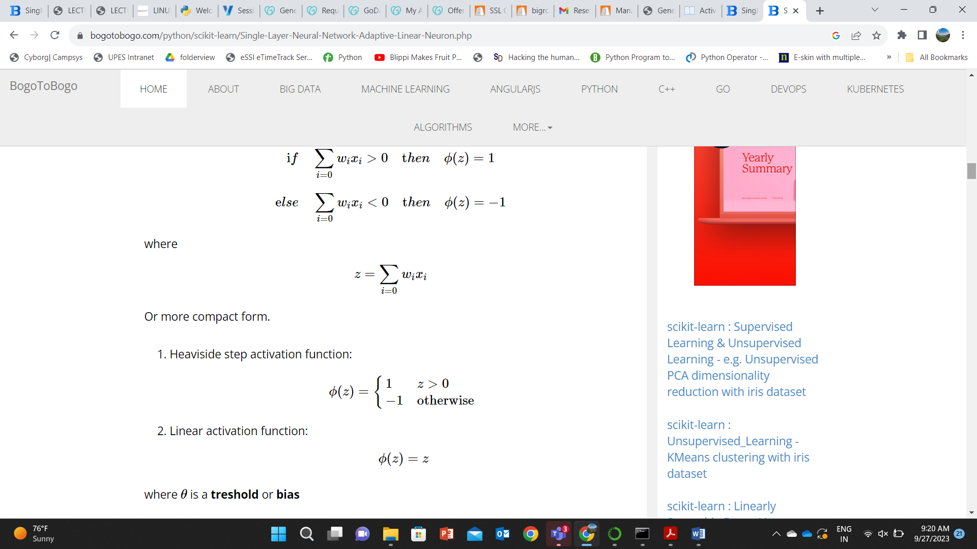

Updating weights

Update of each weight wj in the weight vector w can be written as:

wj:=wj+Δwj

The value of Δwj , which is used to update the weight wj, is calculated as the following:

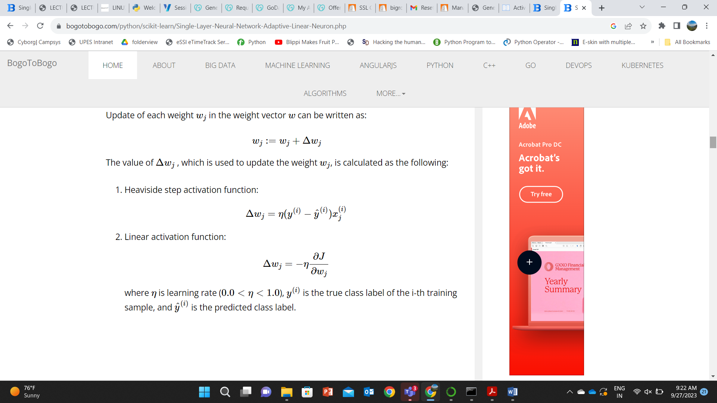

Cost function

One of the most critical tasks in supervised machine learning algorithms is to minimize cost function.

In the case of Adaptive linear neuron, we can define the cost function ***J*** to learn the weights as the Sum of Squared Errors (SSE) between the calculated outcome and the true class label:

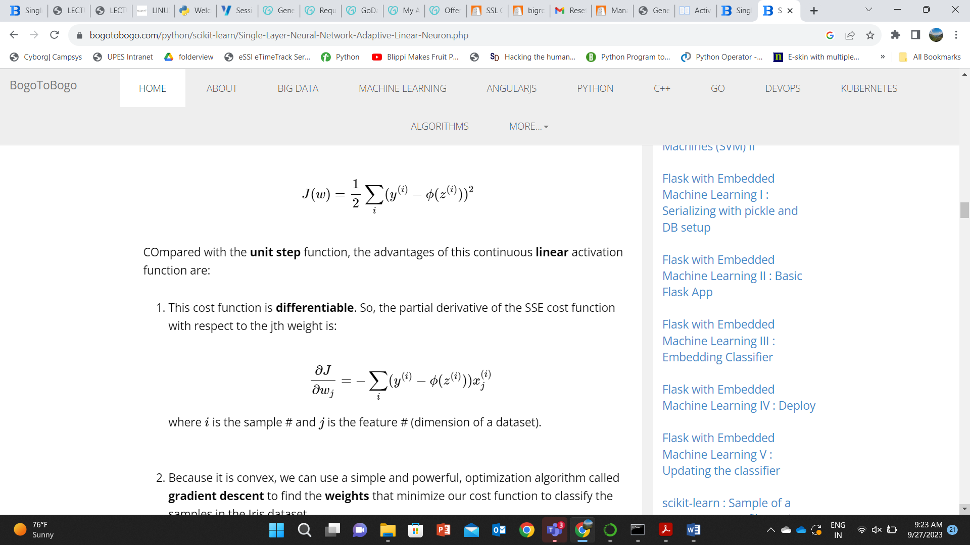

1. Because it is convex, we can use a simple and powerful, optimization algorithm called **gradient descent** to find the **weights** that minimize our cost function to classify the samples in the Iris dataset.

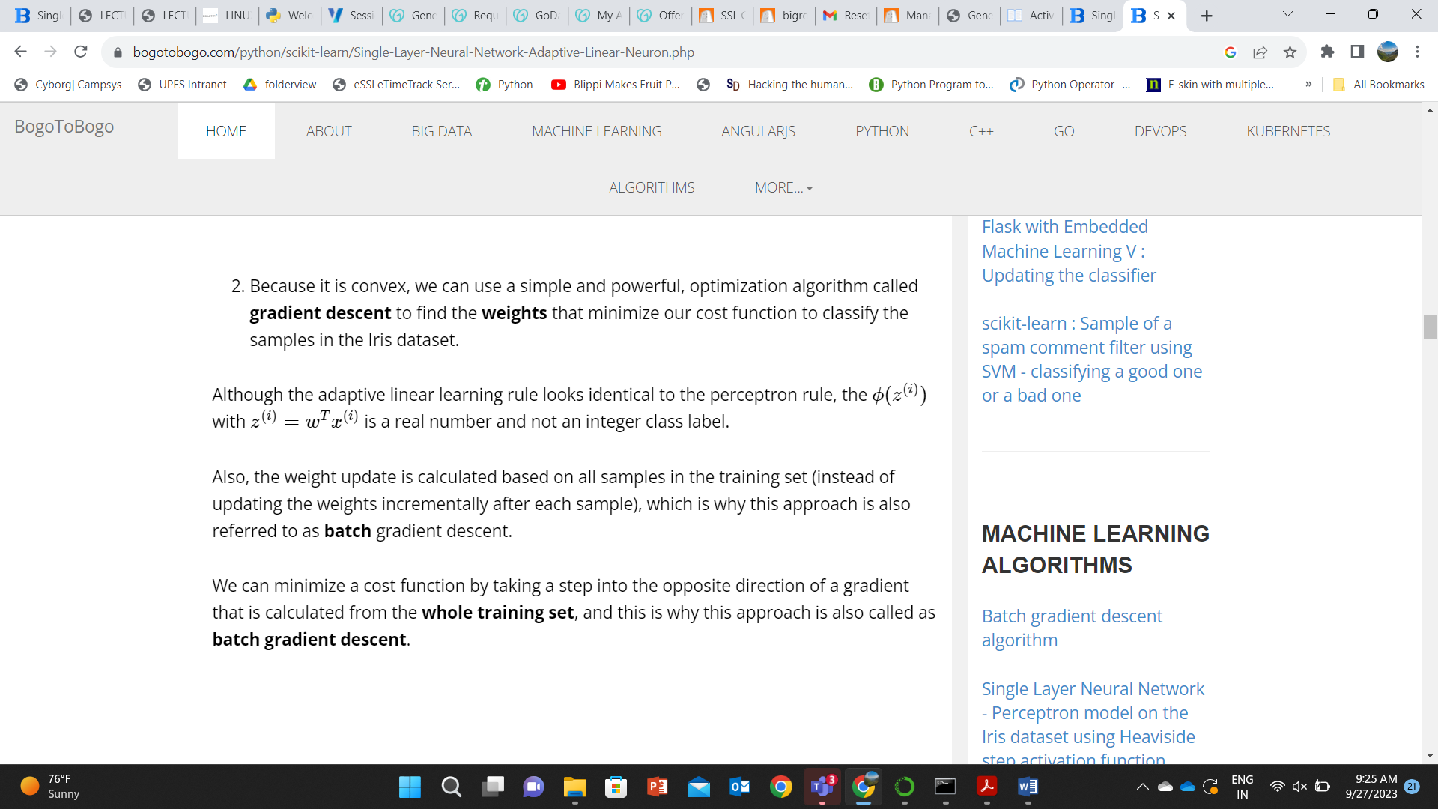

Also, the weight update is calculated based on all samples in the training set (instead of updating the weights incrementally after each sample), which is why this approach is also referred to as **batch** gradient descent.

We can minimize a cost function by taking a step into the opposite direction of a gradient that is calculated from the **whole training set**, and this is why this approach is also called as **batch gradient descent**.

Implementation - Adaptive Linear Neuron

Since the perceptron rule and **Adaptive Linear Neuron** are very similar, we can take the perceptron implementationthat we defined earlier and change the **fit** method so that the weights are updated by **minimizing the cost function** via **gradient descent**.

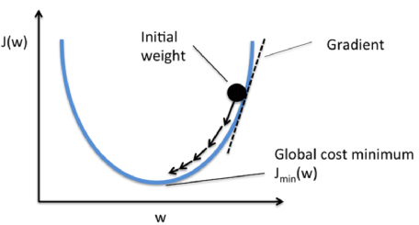

Here is the source code:

import numpy as np

class AdaptiveLinearNeuron(object):

def __init__(self, rate = 0.01, niter = 10):

self.rate = rate

self.niter = niter

def fit(self, X, y):

"""Fit training data

X : Training vectors, X.shape : [#samples, #features]

y : Target values, y.shape : [#samples]

"""

# weights

self.weight = np.zeros(1 + X.shape[1])

# Number of misclassifications

self.errors = []

# Cost function

self.cost = []

for i in range(self.niter):

output = self.net_input(X)

errors = y - output

self.weight[1:] += self.rate * X.T.dot(errors)

self.weight[0] += self.rate * errors.sum()

cost = (errors**2).sum() / 2.0

self.cost.append(cost)

return self

def net_input(self, X):

"""Calculate net input"""

return np.dot(X, self.weight[1:]) + self.weight[0]

def activation(self, X):

"""Compute linear activation"""

return self.net_input(X)

def predict(self, X):

"""Return class label after unit step"""

return np.where(self.activation(X) >= 0.0, 1, -1)

import matplotlib.pyplot as plt

import numpy as np

import pandas as pd

df = pd.read_csv('https://archive.ics.uci.edu/ml/machine-learning-databases/iris/iris.data', header=None)

y = df.iloc[0:100, 4].values

y = np.where(y == 'Iris-setosa', -1, 1)

X = df.iloc[0:100, [0, 2]].values

fig, ax = plt.subplots(nrows=1, ncols=2, figsize=(8, 4))

# learning rate = 0.01

aln1 = AdaptiveLinearNeuron(0.01, 10).fit(X,y)

ax[0].plot(range(1, len(aln1.cost) + 1), np.log10(aln1.cost), marker='o')

ax[0].set_xlabel('Epochs')

ax[0].set_ylabel('log(Sum-squared-error)')

ax[0].set_title('Adaptive Linear Neuron - Learning rate 0.01')

# learning rate = 0.01

aln2 = AdaptiveLinearNeuron(0.0001, 10).fit(X,y)

ax[1].plot(range(1, len(aln2.cost) + 1), aln2.cost, marker='o')

ax[1].set_xlabel('Epochs')

ax[1].set_ylabel('Sum-squared-error')

ax[1].set_title('Adaptive Linear Neuron - Learning rate 0.0001')

plt.show()

Gradient descent

As we can see in the resulting **cost function** plots below, we have two different types of issues.

The left one shows what could happen if we choose a learning rate that is too large. Instead of minimizing the cost function, the error becomes larger in every epoch because we **overshoot** the global minimum.

On the other hand, we can see that the cost decreases for the plot on the right side. That's because we chose the learning rate η=0.0001�=0.0001 is so small that the algorithm would require a very large number of epochs to converge.

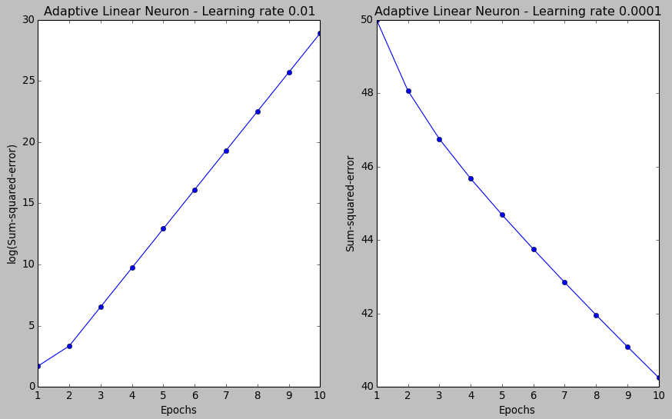

The following figure demonstrates how we change the value of a particular weight parameter to minimize the cost function J� (left). The figure on the right illustrates what happens if we choose a learning rate that is too large, we overshoot the global minimum:

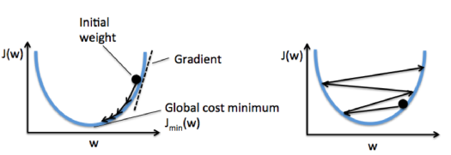

Picture from "Python Machine Learning by Sebastian Raschka, 2015"

Feature scaling

[Feature scaling](https://en.wikipedia.org/wiki/Feature_scaling) is a method used to standardize the range of independent variables or features of data. In data processing, it is also known as **data normalization** and is generally performed during the data preprocessing step.

**Gradient descent** is one of the many algorithms that benefit from feature scaling.

Here, we will use a feature scaling method called **standardization**, which gives our data the property of a **standard normal distribution**.

In machine learning, we can handle various types of data, e.g. audio signals and pixel values for image data, and this data can include multiple dimensions.  
**Feature standardization** makes the values of each feature in the data have **zero-mean** (when subtracting the mean in the enumerator) and **unit-variance**.  
This method is widely used for normalization in many machine learning algorithms (e.g., **support vector machines**, **logistic regression**, and **neural networks**).  
This is typically done by calculating **standard scores**.  
The general method of calculation is to determine the distribution mean and standard deviation for each feature. Next we subtract the mean from each feature. Then we divide the values (mean is already subtracted) of each feature by its standard deviation.  
- from [Feature scaling](https://en.wikipedia.org/wiki/Feature_scaling)

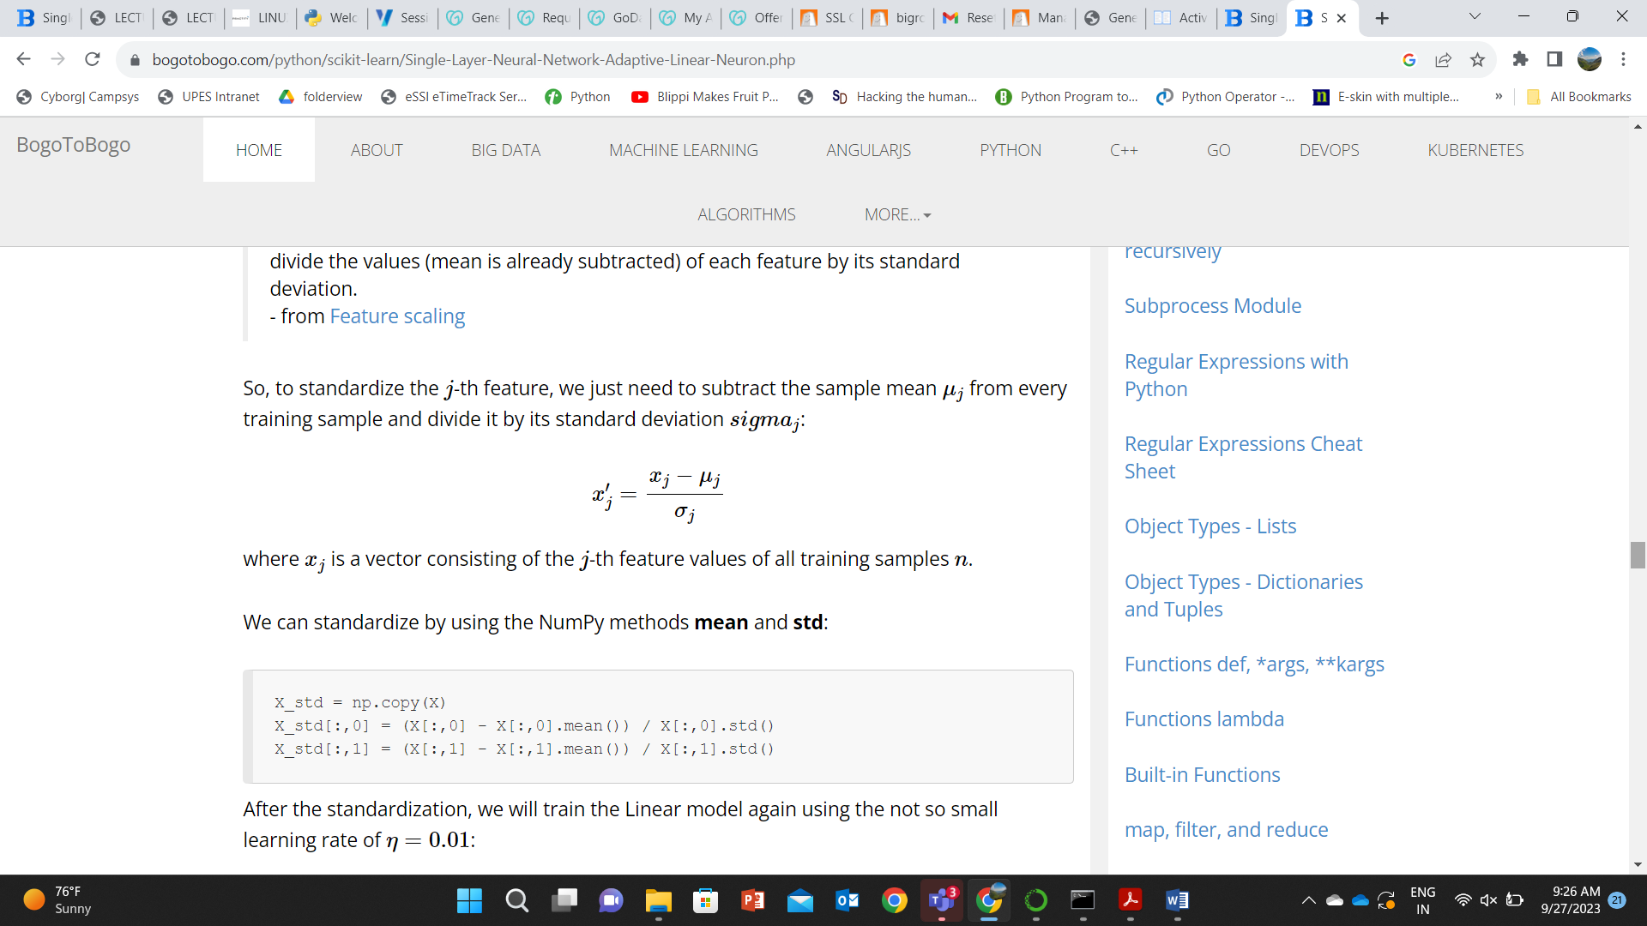

We can standardize by using the NumPy methods **mean** and **std**:

X_std = np.copy(X)

X_std[:,0] = (X[:,0] - X[:,0].mean()) / X[:,0].std()

X_std[:,1] = (X[:,1] - X[:,1].mean()) / X[:,1].std()

After the standardization, we will train the Linear model again using the not so small learning rate of η=0.01 :

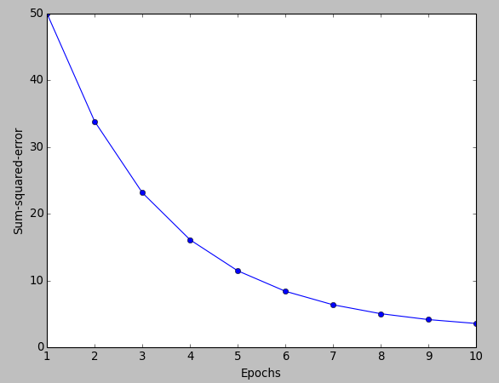  
  
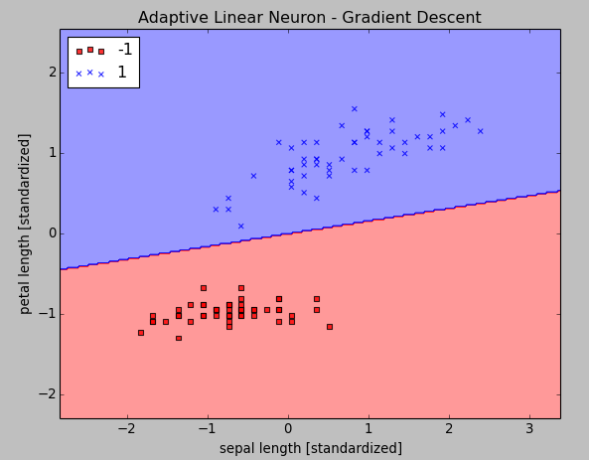

Here is our new code for the two pictures above:

import matplotlib.pyplot as plt

import numpy as np

import pandas as pd

from matplotlib.colors import ListedColormap

class AdaptiveLinearNeuron(object):

def __init__(self, rate = 0.01, niter = 10):

self.rate = rate

self.niter = niter

def fit(self, X, y):

"""Fit training data

X : Training vectors, X.shape : [#samples, #features]

y : Target values, y.shape : [#samples]

"""

# weights

self.weight = np.zeros(1 + X.shape[1])

# Number of misclassifications

self.errors = []

# Cost function

self.cost = []

for i in range(self.niter):

output = self.net_input(X)

errors = y - output

self.weight[1:] += self.rate * X.T.dot(errors)

self.weight[0] += self.rate * errors.sum()

cost = (errors**2).sum() / 2.0

self.cost.append(cost)

return self

def net_input(self, X):

"""Calculate net input"""

return np.dot(X, self.weight[1:]) + self.weight[0]

def activation(self, X):

"""Compute linear activation"""

return self.net_input(X)

def predict(self, X):

"""Return class label after unit step"""

return np.where(self.activation(X) >= 0.0, 1, -1)

def plot_decision_regions(X, y, classifier, resolution=0.02):

# setup marker generator and color map

markers = ('s', 'x', 'o', '^', 'v')

colors = ('red', 'blue', 'lightgreen', 'gray', 'cyan')

cmap = ListedColormap(colors[:len(np.unique(y))])

# plot the decision surface

x1_min, x1_max = X[:, 0].min() - 1, X[:, 0].max() + 1

x2_min, x2_max = X[:, 1].min() - 1, X[:, 1].max() + 1

xx1, xx2 = np.meshgrid(np.arange(x1_min, x1_max, resolution),

np.arange(x2_min, x2_max, resolution))

Z = classifier.predict(np.array([xx1.ravel(), xx2.ravel()]).T)

Z = Z.reshape(xx1.shape)

plt.contourf(xx1, xx2, Z, alpha=0.4, cmap=cmap)

plt.xlim(xx1.min(), xx1.max())

plt.ylim(xx2.min(), xx2.max())

# plot class samples

for idx, cl in enumerate(np.unique(y)):

plt.scatter(x=X[y == cl, 0], y=X[y == cl, 1],

alpha=0.8, c=cmap(idx),

marker=markers[idx], label=cl)

df = pd.read_csv('https://archive.ics.uci.edu/ml/machine-learning-databases/iris/iris.data', header=None)

y = df.iloc[0:100, 4].values

y = np.where(y == 'Iris-setosa', -1, 1)

X = df.iloc[0:100, [0, 2]].values

# standardize

X_std = np.copy(X)

X_std[:,0] = (X[:,0] - X[:,0].mean()) / X[:,0].std()

X_std[:,1] = (X[:,1] - X[:,1].mean()) / X[:,1].std()

# learning rate = 0.01

aln = AdaptiveLinearNeuron(0.01, 10)

aln.fit(X_std,y)

# decision region plot

plot_decision_regions(X_std, y, classifier=aln)

plt.title('Adaptive Linear Neuron - Gradient Descent')

plt.xlabel('sepal length [standardized]')

plt.ylabel('petal length [standardized]')

plt.legend(loc='upper left')

plt.show()

plt.plot(range(1, len(aln.cost) + 1), aln.cost, marker='o')

plt.xlabel('Epochs')

plt.ylabel('Sum-squared-error')

plt.show()